NAME : KOVI SAI GANESH

REGISTER NUMBER : 192124028

COURSE CODE : CSA0520

COURSE NAME : DATABASE MANAGEMENT FOR DATA ANALYTICS

##### Questions:

1. Populate all the five tables with your own data.
2. Update the value of student name whose register number is ‘191711342’
3. Delete the record in the table FACULTY, who resigned her job.
4. Modify the date of birth for the faculty whose name is 'RAM' with a value ‘1983-05-01’.
5. Remove all faculty who are having over 65 years
6. View all the records from the five tables.

1)

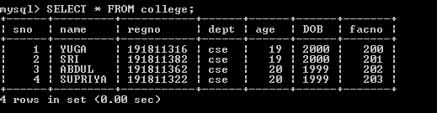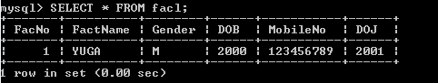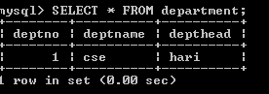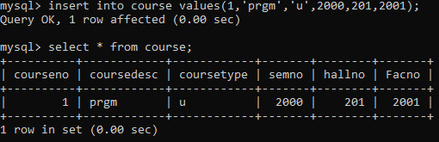

2)



3)



4)

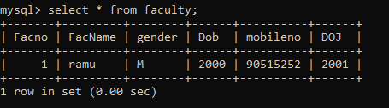

5) 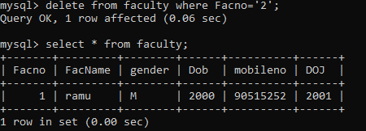

6)

